**UNIT 4TH LONG QUESTION ANSWER (7.5MARKS)-**

**Q.(1)Define quality control process, tools & technique in detail?**

**Ans.**

**Quality control (QC) is a procedure or set of procedures intended to ensure that a manufactured product or performed service adheres to a defined set of quality criteria or meets the requirements of the client or customer. QC is similar to, but not identical with, quality assurance (QA).**

**6 basic Quality control tools-**

**1. Flowchart**

**Most of us are familiar with flowcharts. You have seen flowcharts of reporting relationships in**[**organizational structures**](http://thethrivingsmallbusiness.com/types-of-business-org-structures/)**. Flowcharts are also used to document work process flows. This tool is used when trying to determine where the bottlenecks or breakdowns are in work processes. Flow-charting the steps of a process provides a picture of what the process looks like and can shed light on issues within the process. Flowcharts are also used to show changes in a process when improvements are made or to show a new work flow process.**

### ****2. Check Sheet****

**A check sheet is a basic quality tool that is used to collect data. A check sheet might be used to track the number of times a certain incident happens.**

### ****3. Cause and Effect (fish bone) Diagram****

**A cause and effect diagram, also known as a fish-bone diagram, shows the many possible causes of a problem. To use this tool, you need to first identify the problem you are trying to solve and simply write it in the box (head of the fish) to the right.**

### ****4. Pareto Chart****

**A Pareto chart is a bar graph of data showing the largest number of frequencies to the smallest. In this example, we are looking at the number of product defects in each of the listed categories.**

### ****5. Control Charts****

**Control charts or run charts are used to plot data points over time and give a picture of the movement of that data. These charts demonstrate when data is consistent or when there are high or low outliers in the occurrences of data.**

### ****6. Histograms****

**Histograms are bar chart pictures of data that shows patterns that fall within typical process conditions. Changes in a process should trigger new collection of data.**

### ****7. Scatter Diagrams****

**Scatter diagrams are graphs that show the relationship between variables. Variables often represent possible causes and effect.**

**QUALITY CONTROL METHOD/PROCEDURE-**

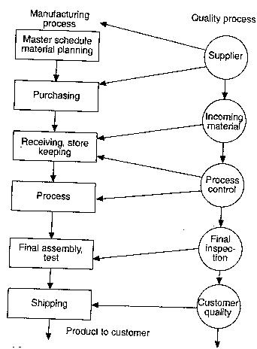

**QUALITY CONTROL TECHNIQUES-**

## Six Sigma

**Six Sigma drew inspiration from the quality improvement methodologies of preceding decades, including**[**quality control**](https://www.boundless.com/management/definition/quality-control)**, TQM, and Zero Defects. It focuses on improving the quality of process outputs by identifying and removing the causes of defects while minimizing the variability in manufacturing and business processes Like TQM, the Six Sigma philosophy asserts that achieving sustained quality improvement requires commitment from the entire organization, particularly top-level management.**

## Just-in-Time ([JIT](https://www.boundless.com/management/definition/jit))

**The Just-in-Time (JIT) method is a production strategy for improving business return on investment by reducing in-process inventory and associated carrying costs. JIT focuses on continuous improvement to maximize an organization's return on investment, quality, and**[**efficiency**](https://www.boundless.com/management/definition/efficiency)**. The JIT inventory system focuses on having "the right material, at the right time, at the right place, and in the exact amount" and defines inventory as a cost**[**factor**](https://www.boundless.com/management/definition/factor)**.**

## Pareto Analysis

**Pareto analysis is a statistical technique used to select a limited number of tasks that produce significant overall effect. It uses the Pareto principle: most problems have a few key causes. Pareto analysis also concludes that 80% of the result can be generated by focusing on 20% of the key work.**

## Five Whys

**The Five Whys is a question-asking technique used to explore the cause-and-effect relationships underlying a particular problem. The primary**[**goal**](https://www.boundless.com/management/definition/goal)**of the technique is to determine the root cause of a defect or problem which points toward a process that is not working well or does not exist.**

**Q.(2) Define Process Control & SQC in detail?**

**Ans.**

**Process control is an engineering discipline that deals with architectures, mechanisms and algorithms for maintaining the output of a specific process within a desired range. For instance, the temperature of a chemical reactor may be controlled to maintain a consistent product output.**

**BENEFITS OF PROCESS CONTROL-**

## Increase throughput from your existing assets

## Increase automation and reduce human intervention

## Reduce rework, concessions and scrap

## Enhance your capability and take on more work

#### Controlling helps in improving the performance of the employees

**PROCESS CONTROL DIAGRAM-**

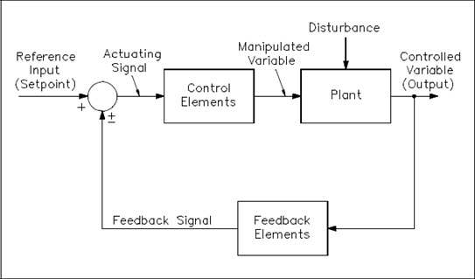

**LIMATATIONS OF PROCESS CONTROL-**

**(1) Difficulty in Setting Qualitative Standards:**

**It is important to note that the setting of standards is possible if the nature of the work is quantitative but in respect of work which is qualitative in nature, the setting of standard is rather difficult and, therefore, for their measurement the help of some indirect standards is taken.**

**(2) No Control over External Factors:**

**It will not be true to say that a manager by completing the function of controlling will be able to establish complete discipline in the organization.**

**(3) Resistance from Employees:**

**The business environment undergoes a constant change. Latest techniques of controlling have to be used in order to face this change. However, the employees oppose these techniques.**

**(4) Costly Affair:**

**In order to implement the process of controlling a lot of money, time and efforts are required. Small organizations cannot bear such expenditure. Therefore, they are useful for only big organizations and for the small organizations they are simply a luxury. The managers should employ only those controlling techniques which yield profit more than their costs.**

**Q.(3)Define control charts?**

**Ans.**

**The control chart is a graph used to study how a process changes over time. Data are plotted in time order. A control chart always has a central line for the average, an upper line for the upper control limit and a lower line for the lower control limit.**

* **Control Chart Basic Procedure**
* **Choose the appropriate control chart for your data.**
* **Determine the appropriate time period for collecting and plotting data.**
* **Collect data, construct your chart and analyze the data.**
* **Look for “out-of-control signals” on the control chart. When one is identified, mark it on the chart and investigate the cause. Document how you investigated, what you learned, the cause and how it was corrected.**

**Out-of-control signals-**

* **A single point outside the control limits. In Figure 1, point sixteen is above the UCL (upper control limit).**
* **Two out of three successive points are on the same side of the centerline and farther than 2 σ from it. In Figure 1, point 4 sends that signal.**
* **Four out of five successive points are on the same side of the centerline and farther than 1 σ from it. In Figure 1, point 11 sends that signal.**
* **A run of eight in a row are on the same side of the centerline. Or 10 out of 11, 12 out of 14 or 16 out of 20. In Figure 1, point 21 is eighth in a row above the centerline.**
* **Obvious consistent or persistent patterns that suggest something unusual about your data and your process.**
* **Continue to plot data as they are generated. As each new data point is plotted, check for new out-of-control signals.**
* **When you start a new control chart, the process may be out of control. If so, the control limits calculated from the first 20 points are conditional limits. When you have at least 20 sequential points from a period when the process is operating in control, recalculate control limits.**

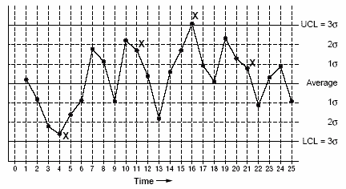

**Types of Control Charts**

**Variables data are quantitative data that can be measured. Some examples are the diameter of a bearing or the thickness of a newly minted coin. Variables data are usually represented as X-bar and R-charts and X-bar and s-charts.**

**Attributes data are qualitative data that can be counted. Some examples are a count of scratches per item or a count of acceptability for a go/no-go gauge. Attributes data are usually represented as nonconforming units and are analyzed by using p, np, c, or u control charts.**

**First, determine what variable you will measure. Then gather data and chart the data accordingly (Figure 2.2)**

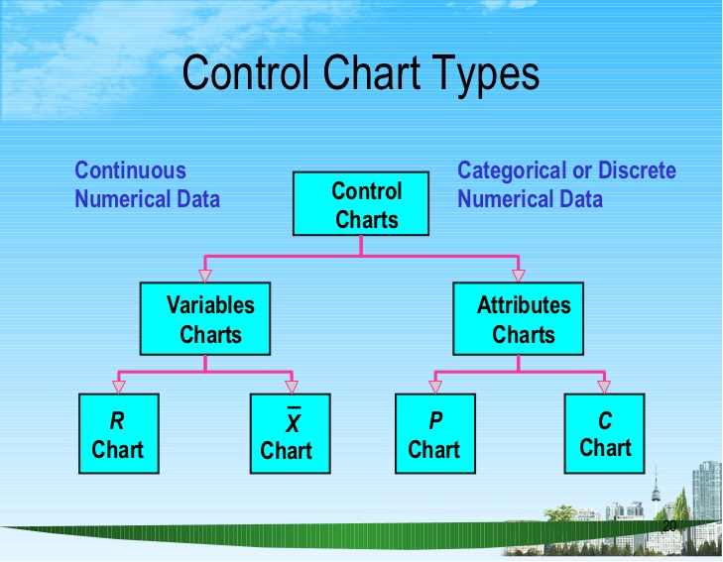

**1)R Chart-**

**In statistical quality control, the and R chart is a type of control chart used to monitor variables data when samples are collected at regular intervals from a business or industrial process**.

**2) X bar chart-** **the X-bar chart is a type of Shewhart control chart that is used to monitor the arithmetic means of successive samples of constant size, n. This type of control chart is used for characteristics that can be measured on a continuous scale, such as weight, temperature, thickness etc.**

**1) P&Np chart-**

**For**[**discrete-attribute**](http://www.brighthubpm.com/six-sigma/30997-six-sigma-data-types/)**data, p-charts and np-charts are ideal. Attribute data is for measures that categorize or bucket items, so that a proportion of items in a certain category can be calculated. Thus a p-chart is used when a control chart of these proportions is desired. An np-chart is appropriate when the number of items used to calculate each proportion is the same.**

**For example, 100 reports may be reviewed each week and categorized as either accurate or inaccurate. The proportion of inaccurate reports could be plotted on a p-chart or the actual number of inaccurate reports could be plotted on an np-chart. If the number of reports reviewed each week varies, then a p-chart must be used.**

**2) C chart-**

**In statistical quality control, the c-chart is a type of control chart used to monitor "count"-type data, typically total number of nonconformities per unit. It is also occasionally used to monitor the total number of events occurring in a given unit of time.**

**Q.(4)Define sampling and also state single ,double ,sequential sampling in detail?**

**Ans.**

**Sampling is the process of selecting units (e.g., people, organizations) from a population of interest so that by studying the sample we may fairly generalize our results back to the population from which they were chosen. Let's begin by covering some of the key terms in sampling like "population" and "sampling frame."**

## Types of Sampling

* **Random sampling is analogous to putting everyone's name into a hat and drawing out several names. Each element in the population has an equal chance of occurring. While this is the preferred way of sampling, it is often difficult to do. It requires that a complete list of every element in the population be obtained. Computer generated lists are often used with random sampling. You can**[**generate random numbers**](https://people.richland.edu/james/ti82/ti-rand.html)**using the TI82 calculator.**
* **Systematic sampling is easier to do than random sampling. In systematic sampling, the list of elements is "counted off". That is, every *k* th element is taken. This is similar to lining everyone up and numbering off "1, 2, 3, and 4; 1, 2, 3, 4; etc". When done numbering, all people numbered 4 would be used.**
* **Convenience sampling is very easy to do, but it's probably the worst technique to use. In convenience sampling, readily available data is used. That is, the first people the surveyor run into.**
* **Cluster sampling is accomplished by dividing the population into groups -- usually geographically. These groups are called clusters or blocks. The clusters are randomly selected, and each element in the selected clusters is used.**
* **Stratified sampling also divides the population into groups called strata. However, this time it is by some characteristic, not geographically. For instance, the population might be separated into males and females. A sample is taken from each of these strata using either random, systematic, or convenience sampling.**

**Single sampling plan-**

**One sample of items is selected at random from a lot and the disposition of the lot is determined from the resulting information. These plans are also denoted as (n, c) plans since there are n observations and the lot is rejected if there are more than c defectives.**

**Double sampling** –

**It is a sampling method which makes use of auxiliary data where the auxiliary information is obtained through sampling. More precisely, we first take a sample of units strictly to obtain auxiliary information, and then take a second sample where the variable(s) of interest are observed.**

**Sequential sampling-**

It **is a non-probabilistic sampling technique, initially developed as a tool for product quality control. The sample size, n, is not fixed in advanced, nor is the timeframe of data collection. The process begins, first, with the sampling of a single observation or a group of observations.**

**Basic Principles of Sampling**   
  
**Theory of sampling is based on the following laws-**  
**• Law of Statistical Regularity – This law comes from the mathematical theory of probability. According to King,” Law of Statistical Regularity says that a moderately large number of the items chosen at random from the large group are almost sure on the average to possess the features of the large group.”  
According to this law the units of the sample must be selected at random.**

**• Law of Inertia of Large Numbers – According to this law, the other things being equal – the larger the size of the sample; the more accurate the results are likely to be.**

**Characteristics of the sampling technique-  
1.Much cheaper.  
2. Savestime.  
3Muchreliable.  
4.Very suitable for carrying out different surveys.  
5. Scientific in nature.**

**Advantages of sampling –**

1**.Veryaccurate.  
2. Economical in nature.  
3. Very reliable.  
4. Highsuitabilityratiotowardsthedifferentsurveys.  
5. Takeslesstime.  
6. in cases, when the universe is very large, then the sampling method is the only practical method for collecting the data.**

**Disadvantages of sampling-**

**1. in adequacy of the samples.  
2. Chances for bias.  
3. Problems of accuracy.  
4. Difficulty of getting the representative sample.  
5. Untrained manpower.  
6. Absence of the informants.  
7. Chances of committing the errors in sampling.**

**Q.(5)Define TQM in detail?**

**Ans.**

**Total Quality Management (TQM) is a management approach that originated in the 1950s and has steadily become more popular since the early 1980s. Total quality is a description of the culture, attitude and organization of a company that strives to provide customers with products and services that satisfy their needs.**

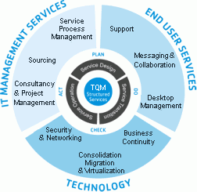

**6 Cs of TQM-**

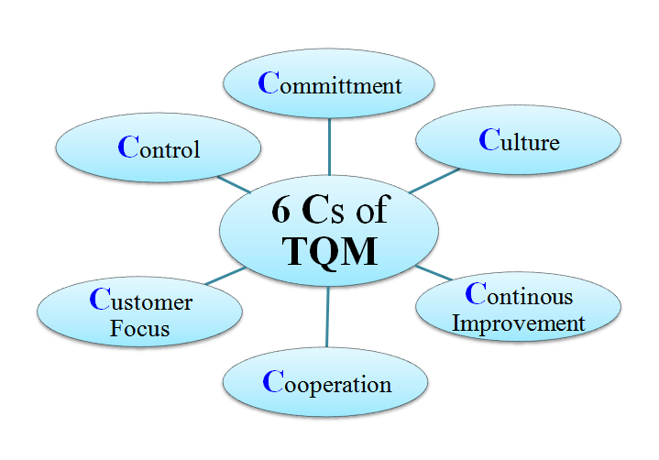

* **Commitment**
* **Culture**
* **Contineous Improvement**
* **Cooperation**
* **Customer Focus**
* **Control**

**TQM is broadly based on the following principles:**

1. **Customer Centric Approach – Consumers are the ultimate judge to determine whether products or services are of superior quality or not. No matter how many resources are pooled in training employees, upgrading machines and computers, incorporating quality design process and standards, bringing new technology, etc.; at the end of the day, it is the customers who have the final say in judging your company. Companies must remember to implement TQM across all fronts keeping in mind the customers.**
2. **Employee Involvement – Ensuring total employee involvement in achieving goals and business objectives will lead to employee empowerment and active participation from the employees in decision making and addressing quality related problems. Employee empowerment and involvement can be increased by making the workspace more open and devoid of fear.**
3. **Continual Improvement – A major component of TQM is continual improvement. Continual improvement will lead to improved and higher quality processes. Continual improvement will ensure companies will find new ways and techniques in producing better quality products, production, be more competitive, as well as exceed customer expectations.**
4. **Strategic Approach to Improvement – Businesses must adopt a strategic approach towards quality improvement to achieve their goals, vision, and mission. A strategic plan is very necessary to ensure quality becomes the core aspect of all business processes.**
5. **Integrated System – Businesses comprise of various departments with different functionality purposes. These functionalities are interconnected with various horizontal processes TQM focuses on. Everyone in the company should have a thorough understanding of the quality policies, standards, objectives, and important processes. It is very important to promote a quality work culture as it helps to achieve excellence and surpass customer expectations. An integrated system ensures continual improvement and helps companies achieve a competitive edge.**
6. **Decision Making – Data from the performance measurement of processes indicates the current health of the company. For efficient TQM, companies must collect and analyze data to improve quality, decision making accuracy, and forecasts. The decision making must be statistically and situational based in order to avoid any room for emotional based decisions.**
7. **Communications – Communication plays a crucial role in TQM as it helps to motivate employees and improve their morale during routine daily operations. Employees need to be involved as much as possible in the day to day operations and decision making process to really give them a sense of empowerment. This creates the environment of success and unity and helps drive the results the TQM process can achieve.**

**Q.(6)Define issues involved in TQM?**

**Ans.**

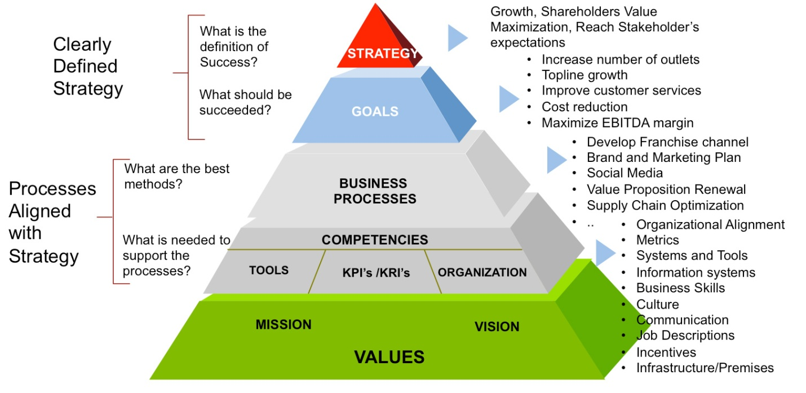

**1. Competitive markets**

**A competitive market is a driving force behind many of the other obstacles to quality. One of the effects of a competitive market is to lower quality standards to a minimally acceptable level. This barrier to quality is mainly a mental barrier caused by a misunderstanding of the definition of quality. Unfortunately, too many companies equate quality with high cost. Their definition leads to the assumption that a company can’t afford quality.**

**2. Bad attitudes/abdication of responsibility/management infallibility**

**The competitive environment, poor management practice, and a general lack of higher expectations have contributed to unproductive and unhealthy attitudes. These attitudes often are expressed in popular sayings, such as “It’s not my job” and “If I am not broke, don’t fix it. Such attitude sayings stem from the popular notion that management is always right and therefore employees are” only supposed to implement management decisions without questioning. Lethargy is further propagated through management’s failure to train employees on TQM fundamentals that build better attitudes by involving them in teams that identify and solve problems.**

**3. Lack of leadership for quality**

**Excess layers of management quite often lead to duplication of duty and responsibility. This has made the lower employees of an organization to leave the quality implementation to be a management’s job. In addition, quality has not been taken as a joint responsibility by the management and the employees. Coupled with the notion that management is infallible and therefore it is always right in its decisions, employees have been forced to take up peripheral role in quality improvement.**

**4. Deficiency of cultural dynamism**

**Every organization has its own unique way of doing things. This is defined in terms of culture of the organization. The processes, the philosophy, the procedures and the traditions define how the employees and management contribute to the achievement of goals and meeting of organizational objectives. Indeed, sticking to organizational culture is integral in delivery of the mission of the organization.**

**5. Inadequate resources for total quality management**

**Most companies do not involve quality in their strategic plan; little attention is paid to TQM in terms of human and financial resources. Much of the attention is drawn to increasing profit margins of the organization with little regard as to whether their offers/ supply to customers is of expected quality. There is paltry budgetary allocation made towards employee training and development which is critical for total quality management implementation.**

**6. Lack of customer focus**

**Most strategic plans of organizations are not customer driven. They tend to concentrate much on profit-oriented objectives within a given time frame. Little (if any) market research is done to ascertain the product or service performance in the market relative to its quality. Such surveys are regarded by most organizations as costly and thus little concern is shown to quality improvement for consumer satisfaction.**

**7. Lack of effective measurement of quality improvement**

**TQM is centered on monitoring employees and processes, and establishing objectives that anticipate the customer's needs so that he is surprised and delighted. This has posed a considerable challenge to many companies. Measurement problems are caused by goals based on past substandard performance, poor planning, and lack of resources and competitor-based standard.**

**8. Poor Planning**

**The absence of a sound strategy has often contributed to ineffective quality improvement. Duran noted that deficiencies in the original planning cause a process to run at a high level of chronic waste. Using data collected at the recent seminars, Duran (1987) reported that although some managers were not pleased with their progress on their quality implementation agenda, they gave quality planning low priority.**

**A quality implementation program will succeed only if top management is fully committed beyond public announcements. Success requires devotion and highly visible and articulate champions.**

**10. Resistance of the workforce**

**A workforce is often unwilling to embrace TQM for a variety of reasons. Oakland (1989) explained that a lack of long-term objectives and targets will cause a quality implementation program to lose credibility.**

**11. Lack of proper training/Inadequate Human Resource Development**

**There is evidence that lack of understanding and proper training exists at all levels of any organization, and that it is a large contributor to worker resistance And training presents a major obstacle in the development and implementation of a quality program.**

**QUALITY IMPROVEMENT DIAGRAM-**

